Кондратюк Данило

ПД-22

Лаба 2

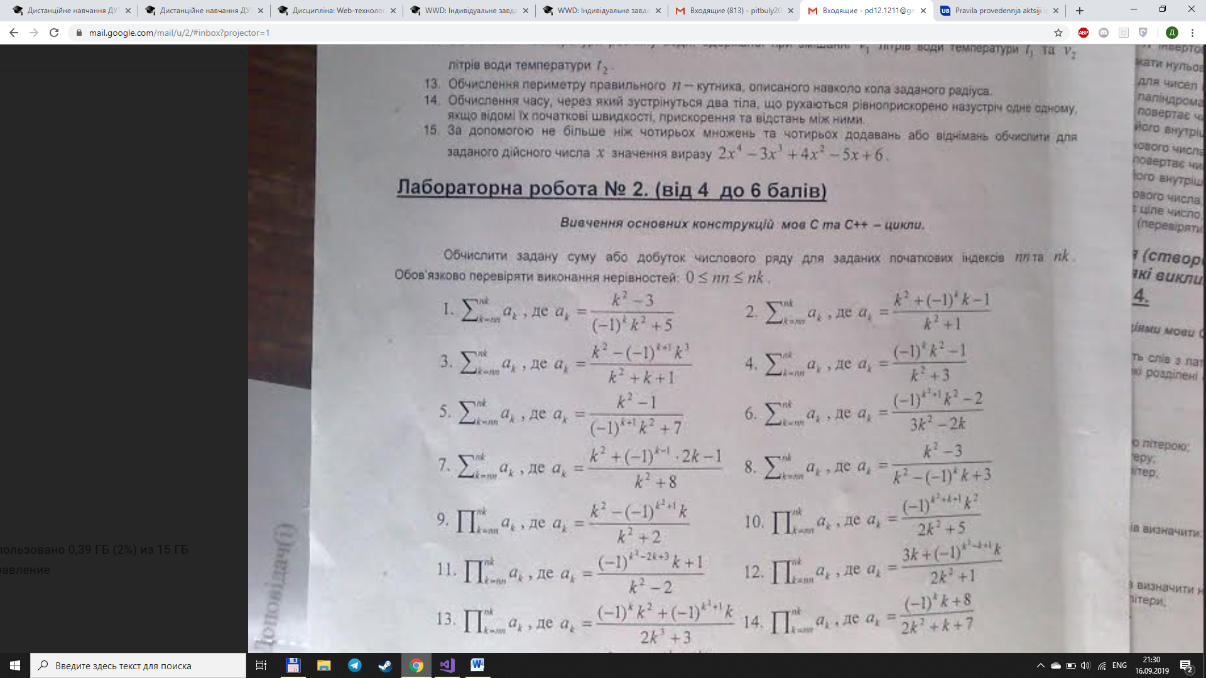

using System;

using System.Collections.Generic;

using System.Linq;

using System.Text;

using System.Threading.Tasks;

namespace ConsoleApp1

{

class Program

{

static void Main(string[] args)

{

int nn;

int nk;

do

{

Console.Write("nn = ");

nn = int.Parse(Console.ReadLine());

if (0 > nn)

{

Console.WriteLine("Error! nn must be < 0");

}

} while (0 > nn);

do

{

Console.Write("nk = ");

nk = int.Parse(Console.ReadLine());

if(nn > nk)

{

Console.WriteLine("Error! nk must be > nn");

}

} while (nn > nk);

double a = 1;

for (int k = nn; k <= nk; k++)

{

a \*= (Math.Pow(-1, (Math.Pow(k, 2) - 2 \* k + 3)) \* k + 1) / (Math.Pow(k, 2) - 2);

}

Console.WriteLine($"a = {a}");

Console.ReadKey();

}

}

}

